Lab Guide for MS Excel







Author(s) | Rekha T S
Authorized by
Creation/Revision Date
Version

COPYRIGHT NOTICE

All ideas and information contained in this document are the intellectual property of Education and Research Department, Infosys Technologies Limited. This document is not for general distribution and is meant for use only for the person they are specifically issued to. This document shall not be loaned to anyone, within or outside Infosys, including its customers. Copying or unauthorized distribution of this document, in any form or means including electronic, mechanical, photocopying or otherwise is illegal.

Education and Research Department
Infosys Technologies Limited
Electronics City
Hosur Road
Bangalore - 561 229, India.

Tel: 91 80 852 0261-270
Fax: 91 80 852 0362
www.infy.com
mailto:E&R@infy.com

Document Revision History

Version | Date | Author(s) | Reviewer(s) | Comments
1.0 |  |  |  | Initial Draft
2.0

Contents

COPYRIGHT NOTICE ii
Document Revision History i
Contents ii
Context 1
1 Overview of MS Excel 1
2 Data Editing 2
2.1.1 Rows & Columns 2
2.1.2 Opening & Saving Worksheet 3
2.1.3 Creating Spreadsheet 4
2.1.4 Data Entry 4
2.1.5 Selecting cells with mouse 5
2.1.6 Deleting cells 6
2.1.7 Moving Through Cells 6
2.1.8 Moving and Copying Cells 6
2.1.9 Formatting Cells 7
2.1.10 Format Painter 8
2.1.11 Resizing Rows and Columns 8
2.1.12 Formatting the cell with font color 9
2.2 Auto Format 9
2.3 Conditional Formatting 11
2.4 Auto fill & Fill Series 14
2.5 Inserting an Object 16
2.6 Data validation 16
2.7 Auto Filter & Advanced Filter 19
2.8 Data Sorting 21
Basic Sorts 21
Complex Sorts 21
2.9 Protecting the Sheets & Workbook 22
3 Formulae and Functions 24
Formulae 24
Formula palette-Built-in functions 25
Auto sum 26
3.1 Rarely used Functions 27
3.1.1 Date & Time Functions 27
3.1.2 Statistical Functions 27
3.1.3 Logical Functions 28
3.1.4 Text based Functions 29
3.1.5 Mathematical Functions 30
4 Vlookup / Hlookup 30
5 Charts & Graphs 31
5.1 Contents of the charts 32
5.2 Types of Charts 32
6 Pivot Table 34
6.1 Steps to create Pivot Table Report 34
7 Printing the Excel data 38

Context
This document contains step by step Lab guide on the usage of MS Excel 2007

Note: All assignments in this document must be completed in the sequence in this document in order to complete the course. It is advisable to study & practice the examples incorporated in the Slides before starting with the below assignments/exercises.

Objective: To learn about using MS Excel 2007.

Background: A Spread Sheet is a computer Application which contains worksheet with the matrix of rows & columns. MS Excel is a one of the best examples of Spread Sheet.
Excel has been used to,
  - Perform detailed analysis of numeric data.
  - Define Formulae to perform calculations on the given data.
  - Linking spreadsheets & representing in the form of graphs.
  - Recalculate the data.
A workbook is made up of Cells.
A single worksheet consists of 10,48,576 rows and 16,384 columns

Overview of MS Excel

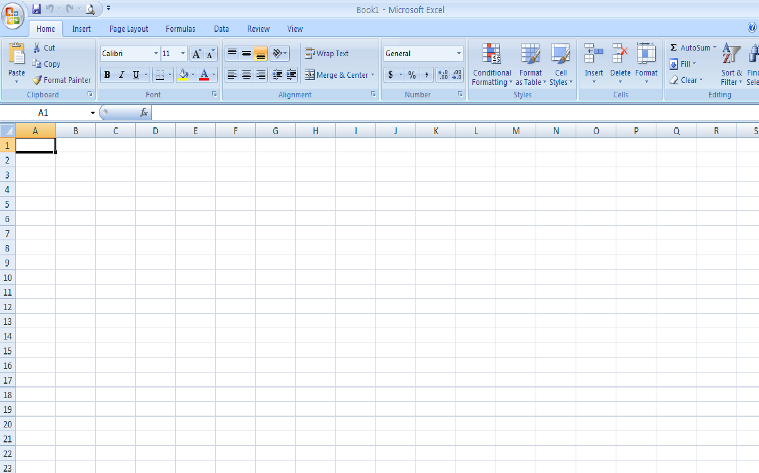
1
2
3
4
5
6

Description of the Screen Layout
- Title Bar: States the Title of the Excel Sheet. By default, title would be “Book1 – Microsoft Excel”
- Columns: Are labeled alphabetically i.e. A, B, C…Z. After that it continues with AA,Ab,AC…AZ . BA,BB,BC…BZ and so on.
- Rows: Are numbered as 1,2,3… and so on.
- Name Box: Represents name of the cell
- Formula Bar: Contents of the cells are displayed
- Cell: Intersection of a row and column

Data Editing

Rows & Columns
Rows and Columns can be added by right clicking on the Row / column

To add a row
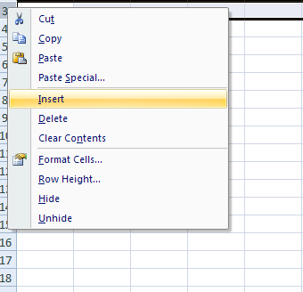

To add a column
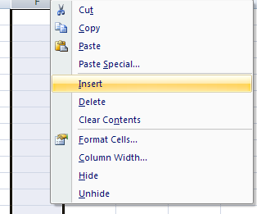

Opening & Saving Worksheet

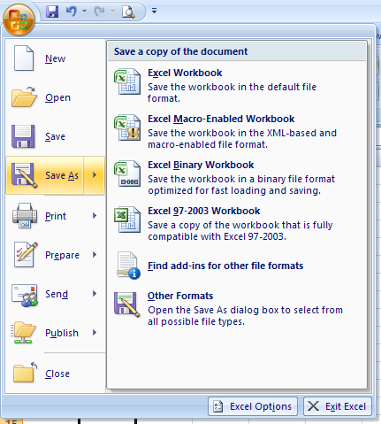

Note: Save As option is used to save the document in the other ver of Excel

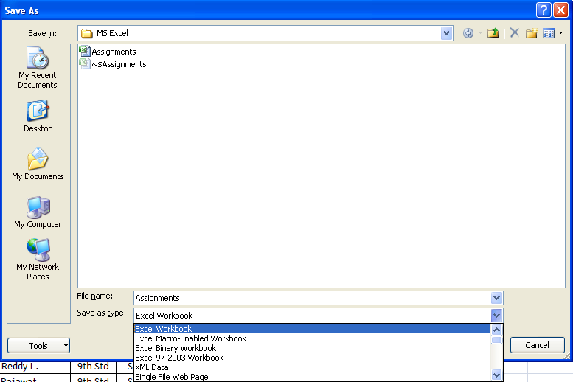

Creating Spreadsheet

When the Excel is started, a blank worksheet opens automatically.
OR,
Select Office button to click on New button to create a new workbook.
Select Office button to click on Open button to create an existing workbook.

Data Entry
To enter the data in a worksheet, click the cell and type the value. Press Enter to conclude entry. Entered text would appear in the active cell and in the formula bar

Excel gives different formats for the data which we enter in the cell. When the information is entered for the first time, the default format of the cell is General, which applies no particular format to the information type.
To apply the relevant type to the data,
- Highlight the column range you wish to format
- Click on Home tab, select Font option
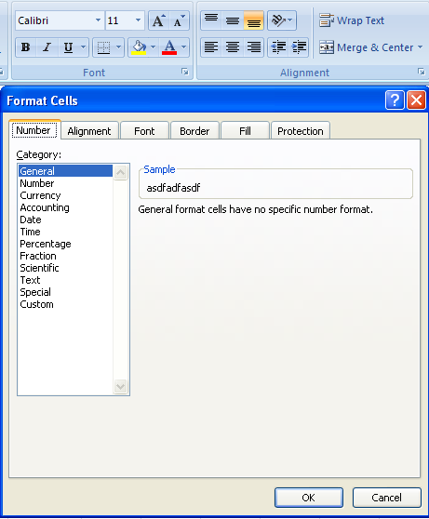

- Select the relevant data type from the Category and click OK

Selecting cells with mouse

- To select a single cell, simply point and click on it to make it active.
- Click on a row number to select the entire row
- Click on the column alphabet to select the entire column
- To select a range of cells, click and drag the mouse over cells
- To select the entire worksheet, click on the empty cell at the intersection of row and column at the beginning of the worksheet

Deleting cells
To delete cells:
- Select the cell, the range, or the row or column you want to delete.
- From the Home Menu, in Cells option, select Delete. Or, right-click the selection and select Delete from the shortcut menu.

Moving Through Cells
To move through the cells of a worksheet following keystrokes can be used.
Movement | Key stroke
One cell up | up arrow key
One cell down | down arrow key or ENTER
One cell left | left arrow key
One cell right | right arrow key or TAB
Top of the worksheet (cell A1) | CTRL+HOME
End of the worksheet (last cell containing data) | CTRL+END
End of the row | CTRL+right arrow key
End of the column | CTRL+down arrow key
Any cell | File|Go To menu bar command

Moving and Copying Cells
Moving Cells
To cut cell contents that will be moved to another cell select Home|Clipboard, click the Cut button on the standard toolbar.
Copying cells
To copy the cell contents, select Clipboard option in Home Menu, click on the Copy button.
Pasting Cut and Copied Cells
Highlight the cell where the cut or copied content has to be pasted, select Paste option from clip board option in Home menu.

Formatting Cells
Numbers in Excel can be formatted in a variety of ways: as whole numbers, as decimals, as percentages, and even as currency. By default, numbers use the General format-this displays numbers exactly as you enter them
To apply a different number format to the contents of a cell:
- Select the cell.
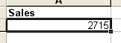
- Right click on the cell and click on Format Cells
The Format Cells dialog opens.
3. Select the Number tab.
- All the available number formats are listed under Category. Select a category, such as Currency.
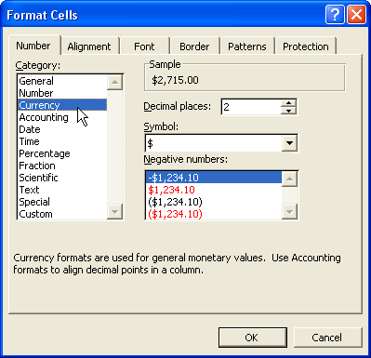
- Formatting options for that category appear on the right side of the dialog. Select the options you want, such as the number of decimal places to use.
- Click OK.
- The formatting is applied to the selected cell (or range of cells).
Other tabs available in Format Cells,
Alignment tab - These options helps us to change the position and alignment of the data within the cell.
Font tab - All of the font attributes are displayed in this tab including font face, size, style, and effects. Highlight the cells and apply the desired font from this tab.
Border and Pattern tabs - These tabs allow us to add borders, shading, and background colors to a cell.

Format Painter
This option is used to copy the format from one place and apply to the other. Format Painter option .
Steps to use Format Painter,
- Highlight the already formatted data
- Go to Home tab
- Click on Format Painter
- Click on the data which you want to format
- Double click will keep the format painter enabled until you press escape to close it.

Resizing Rows and Columns
There are two ways to resize rows and columns.
- Resize a row by dragging the line below the label of the row.
- Resize a column in a similar manner by dragging the line to the right of the label of the column
- OR -
- Click the row or column label and select Format option in Home menu
- Specify the height of the row or width of the column by entering a numerical value.
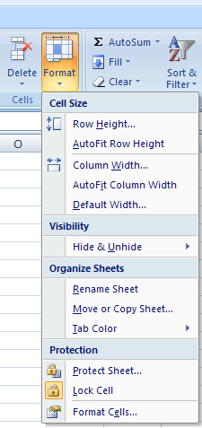

Formatting the cell with font color
Select the cell that you want to format, click on the color to set either the background color or the font color of the cell

Auto Format
In-built Auto Format feature in Excel helps the user to go for quick formatting of the table or data.
Steps to use Auto Format feature,
- Prepare the table
- Select Style option on Home menu
- Click on Cell Styles
- Select the required Style
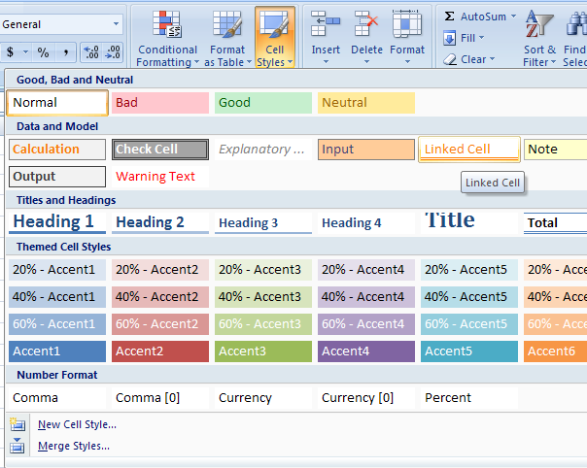
- Your data would be Auto formatted with the new style
Emp NO. | DoJ | Gender | NAME | Batch | Current Allocation
104026 | 11-Jan-08 | Ms. | Shweta Paliwal | Jan08LC2 | Mainframe
103898 | 11-Jan-08 | Mr. | Mahendra Sanghvi | Jan08LC2 | Finacle
104094 | 11-Jan-08 | Mr. | Vikram Nayak A. | Jan08LC2 | Open System
103827 | 11-Jan-08 | Mr. | Ashwin Shankarananda | Jan08LC2 | Finacle
103828 | 11-Jan-08 | Mr. | Aswini Ray | Jan08LC2 | Finacle
104045 | 11-Jan-08 | Mr. | Srisailachari Kolakaluri | Jan08LC2 | Mainframe
103986 | 11-Jan-08 | Mr. | Ravitheja Somisetty | Jan08LC2 | Finacle
104044 | 11-Jan-08 | Mr. | Srinivasan Ranganathan | Jan08LC2 | Mainframe
103873 | 11-Jan-08 | Mr. | K. V. Sreevathsava | Jan08LC2 | Mainframe
104099 | 11-Jan-08 | Mr. | Vini Bhat | Jan08LC2 | Finacle

Conditional Formatting
This feature allows the user to set the formatting of the table or data by applying conditions. Such conditions could be either on the value of a cell or on the value of a formula.
Problem Description: We have marks scored in core subjects for 9th Std students. We want to highlight marks with below passing range by setting the rule and highlight the marks with distinction by setting the rule.
Click here for the Assignment 1 → 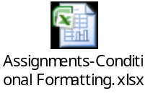
Follow the below steps to solve the assignment,
- Select the Maths – Marks column
- Click on Home tab
- Go to Styles Option
- Click on Conditional Formatting
- Click on New Rule
- Select the Rule Type -> “Format Only Cells that contain”
- Click on Cell value -> Less than -> 50 as shown below,
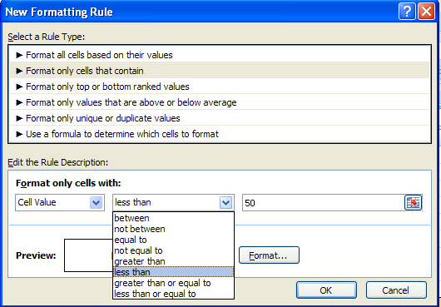
- Click on Format
- Select the color – “Red” with “Bold Italic” – as shown below,
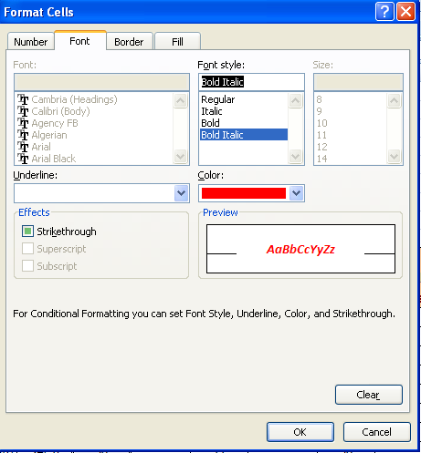
- Click on OK
- Repeat the process for Science – Marks and Social –Marks columns also
- Solve the last assignment as mentioned in embedded book.

Assignment 2 is available in the same attachment
Problem Description: Stock Market movements of BSE sensex are collected. Changes need to be highlighted as mentioned below,
Positive changes to be highlighted in Green Color – Bold
Negative changes to be highlighted in Red color - Bold

Auto fill & Fill Series
The Autofill feature allows us to quickly fill cells with repetitive or sequential data such as dates, numbers, and repeated text.
- Type the number, date or the text that will be repeated into a cell.
- Select the handle at the bottom, right corner of the cell with the left mouse button and drag it down as many cells as you want to fill.
- Release the mouse button.
If you want to autofill a column with cells displaying the series of numbers or date you must enter first two values in the series into two adjacent cells in a column. Highlight the two cells and drag the handle of the selection with the mouse.
Auto filling Functions
Autofill can also be used to copy functions. In the example below, column A and column B each contain lists of numbers and column C contains the sums of columns A and B for each row. The function in cell C2 would be "=SUM (A2:B2)". This function can then be copied to the remaining cells of column C by activating cell C2 and dragging the handle down to fill in the remaining cells. The autofill feature will automatically update the row numbers as shown below if the cells are referenced relatively.
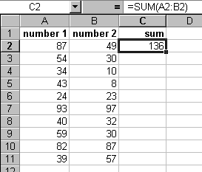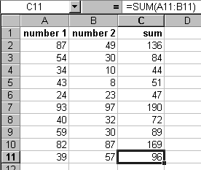

Fill Series:
When a specific amount of data needs to be filled in columns or rows, Fill series option can be chosen by specifying the step value and stop value.
Problem Description: We have 8th, 9th & 10th Std students taking the exams in 9 different classrooms and final Examination seating list need to be placed on the notice board.
Click here for the Assignment → 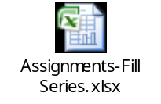
Follow the below steps to solve the assignment,
- Enter 1 in the cell E7
- Select Home tab
- Go to Editing Option
- Click on Fill → Series
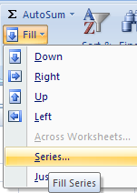
- Enter 1 in the step Value and 25 in the stop Value (depending on the classroom Capacity)
- Choose Column in Series in option
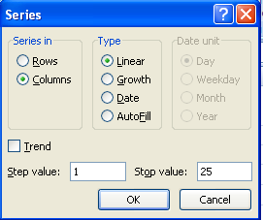
- Click on Ok
- Repeat the process for other classrooms

Inserting an Object

A File or a Link to the file can be embedded in an excel sheet for a very quick reference.

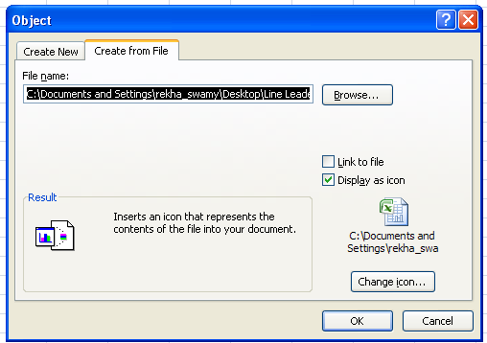

Data validation
This feature helps the user to define what type of data to be entered in the cell. For example, if a user wants to enter the numbers between 1 and 50, a cell can be validated with the specified criteria.

Types of data you can validate are,
- Values from the list
- Numbers within limits
- Dates or times within a time frame
- Text of a specified length

Problem Description: School Authority has decided to issue T-Shirts for the students in 9th Std. It has decided to collect the size of the T-Shirt from the students. Excel sheet need to be data validated with the appropriate error message.

Click here for the assignment → 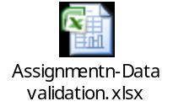

Steps to be followed to solve the assignments are,
  - Select the cell D9
  - Select Data menu
  - Go to Data Tools Option
  - Click on Data validation option
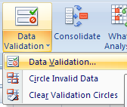

  - Select the validation criteria – List
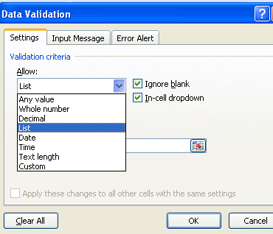

  - Enter the values
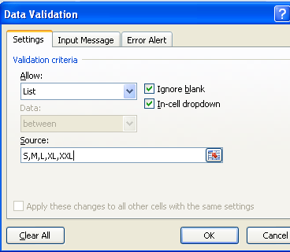

Note: Values are case sensitive

  - Enter the Input Message
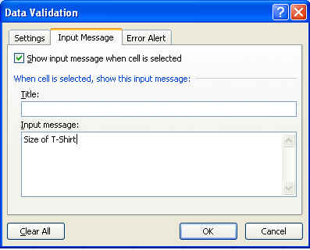

  - Enter the Error Message Alert
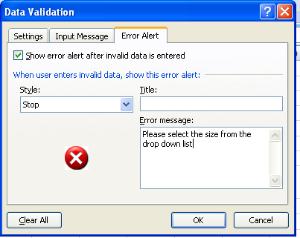

  - Click on OK

Auto Filter & Advanced Filter
Data filter has been used to display only those rows which meet the set criteria.

Steps to create Auto filter,
    - Select the range of cells where you want to place the filter
    - Click on Data menu
    - Click on Filter option
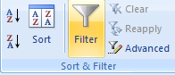

    - Click on the small arrow to get the drop down list
    - In the below example to click on the small down arrow to filter on Section column
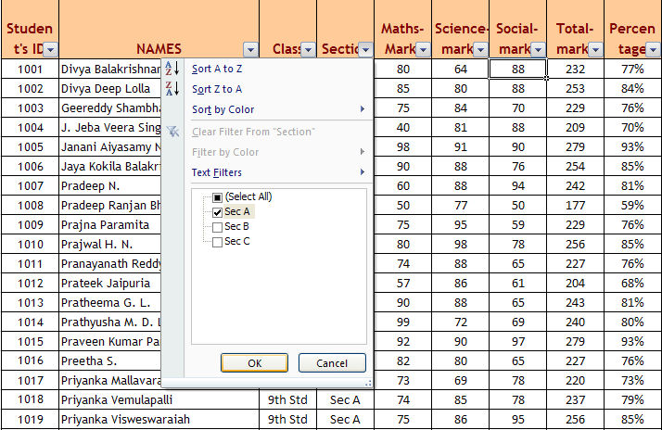

    - Filtered data looks as show below,
Student's ID | NAMES | Class | Section | Maths-Marks
1001 | Divya Balakrishnan | 9th Std | Sec A | 80
1002 | Divya Deep Lolla | 9th Std | Sec A | 85
1003 | Geereddy Shambhavi Reddy | 9th Std | Sec A | 75
1004 | J. Jeba Veera Singh | 9th Std | Sec A | 40
1005 | Janani Aiyasamy Narasimhamurthy | 9th Std | Sec A | 98
1006 | Jaya Kokila Balakrishnan | 9th Std | Sec A | 90
1007 | Pradeep N. | 9th Std | Sec A | 60
1008 | Pradeep Ranjan Bhattacharya | 9th Std | Sec A | 50
1009 | Prajna Paramita | 9th Std | Sec A | 75
1010 | Prajwal H. N. | 9th Std | Sec A | 80
1011 | Pranayanath Reddy Anantula | 9th Std | Sec A | 74
1012 | Prateek Jaipuria | 9th Std | Sec A | 57

    - To set the specific criteria for filtering the data, use Advance filter
    - Use the attached table to know more on Advanced filter → 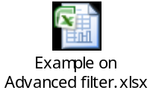

Data Sorting
Basic Sorts
To execute a basic descending or ascending sort based on one column, highlight the cells that will be sorted and click the Sort Ascending (A-Z) button or Sort Descending (Z-A) button on the standard toolbar.
Complex Sorts
To sort by multiple columns, follow these steps:
- Highlight the cells, rows, or columns that will be sorted.
- Select Data|Sort from the menu bar.
- From the Sort dialog box, select the first column for sorting from the Sort By drop-down menu and choose either ascending or descending.
- Select the second column and, if necessary, the third sort column from the Then By drop-down menus.
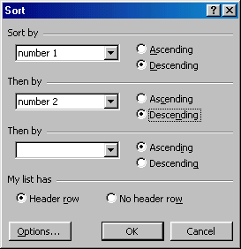
- If the cells you highlighted included the text headings in the first row, mark My list has...Header row and the first row will remain at the top of the worksheet.
- Click the Options button for special non-alphabetic or numeric sorts such as months of the year and days of the week.
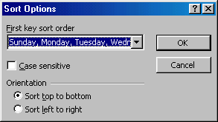
Click OK to execute the sort.

Protecting the Sheets & Workbook
When you want to restrict the user in updating certain fields, you can protect your document with password

Steps to protect the sheet includes,
    - Select the cells which the user wants to edit.
      - Note that non-selected cells would be protected
    - Uncheck the Locked check box

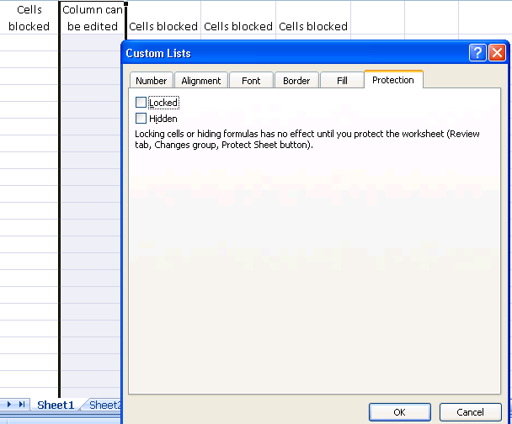

    - Click on Review tab
    - Select Protect Sheet option
    - Enter the password
    - Re-enter the password
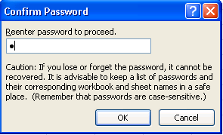

    - Cells selected can be edited
    - Cells not selected would be protected
    - To unprotect the sheet, enter the password

Formulae and Functions
Excel allows us to create mathematical Formulae and execute functions. A formula is an equation that calculates a value for a cell or a range of cells.
Formulae
Formula is entered into the formula bar preceded by an equal (=) sign. The formula then includes the addresses of the cells with appropriate operands placed in between. After the formula is typed into the cell, the calculation executes immediately and the formula itself is visible in the formula bar.
Once the formula is entered in the formula bar, cells display the resulting values of the Formulae, rather than the Formulae themselves. Because Formulae can refer to other cells in a worksheet, other worksheets, or even other workbooks, the value of a cell containing a formula will change as the contents of the referenced cells change.
To enter a formula into a cell:
- Select the cell.
- In the formula bar, enter an equal (=) sign, and then type the formula.
- Press Enter.
Similarly, a formula contained in a cell can be viewed by clicking the cell. When the cell is selected, the formula is displayed in the formula bar.
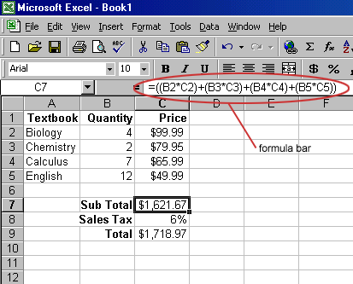
Formula can be edited by changing it in the formula bar and press Enter.
The simplest Formulae can use familiar operators, such as:
- The plus sign (+) for addition
- The minus sign (-) for subtraction
- The asterisk (*) for multiplication
- The backslash (/) for division

Linking Worksheets
Sometimes it is required to use the value from a cell in another worksheet within the same workbook in a formula. For example, the value of cell B1 in the current worksheet and cell B2 in the second worksheet can be added using the format "sheetname!celladdress". The formula for this example would be "=B1+Sheet2!B2" where the value of cell B1 in the current worksheet is added to the value of cell B2 in the worksheet named "Sheet2".
Relative and Absolute Referencing
Referencing cells by just their column and row labels (such as “A1”) are called relative referencing. When a formula contains relative referencing and it is copied from one cell to another, Excel does not create an exact copy of the formula. It will change cell addresses relative to the row and column they are moved to. For example, if a simple addition formula in cell C1 "=(A1+B1)" is copied to cell C2, the formula would change to "=(A2+B2)" to reflect the new row.
In absolute referencing,when Formulae are copied from one cell to another, cell addresses will not change relatively. It is accomplished by placing dollar signs "$" within the cell addresses in the formula.
Continuing the previous example, the formula in cell C1 would read "=($A$1+$B$1)" if the value of cell C2 should be the sum of cells A1 and B1. Both the column and row of both cells are absolute and will not change when copied.
Formula palette-Built-in functions
Excel's Formula Palette allows us to construct a formula with the help of list of the built-in functions. To access the Formula Palette:
- Select the cell in which you want to enter the formula.
- Click the Edit Formula button in the formula bar.
- The Formula Palette opens.
- From the Functions drop-down menu, select a required function that describes the type of calculation you want to perform.
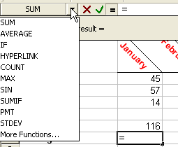
Note: Select More Functions to see additional functions.
- The Formula Palette displays fields to enter the arguments (the values to be calculated), as well as a description of the function and the current result of the calculation. Enter the values you want calculate into the Number 1 field. Click OK

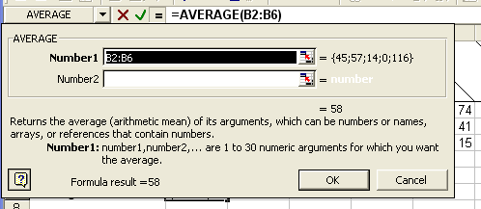

Auto sum
Auto sum function can be used to add the contents of a cluster of adjacent cells.
- Select the cell where the sum will appear which should be outside cluster of cells whose values will be added(C2 in the example)
- Click the Autosum button (Greek letter sigma) on the standard toolbar.
- Highlight the group of cells that will be summed (cells A2 through B2 in this example).
- Press the ENTER key on the keyboard or click the green check mark button on the formula bar .
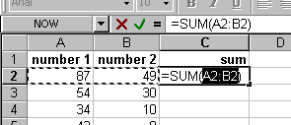

Rarely used Functions

Date & Time Functions
- =Now() à returns today’s date & time
- = Today() à returns today’s date
- = Networkdays() à returns the no. of working dates between two days
Argument includes,
    - Start_Date: Is a day that represents the start date
    - End_Date: is a date that represents the end date
    - Holidays: is an optional range of one or more dates to exclude from the working calendar.
Eg., =NETWORKDAYS("1-Apr-2008","30-Apr-2008") –Returns 22

Statistical Functions
- =Count() à Counts the values within the parenthesis
Eg., =COUNT(1,2,3,4,5,6,7) – Returns 7

- =Average() à returns average (arithmetic mean) of the argument
Eg., =AVERAGE(12.4,23.4,5.6,6.9) – Returns 12.075

- = Averageif() à returns the average (arithmetic mean) of all the cells in a range that meet a given criteria.

Eg., From the below table,
=AVERAGEIF(E:E,"Sec A",F:F) – Returns 73.33

To calculate Average Marks scored by Sec A
Student's ID | NAMES | Class | Section | Maths-Marks
1001 | Divya Balakrishnan | 9th Std | Sec A | 80
1002 | Divya Deep Lolla | 9th Std | Sec A | 85
1003 | Geereddy Shambhavi Reddy | 9th Std | Sec A | 75
1004 | J. Jeba Veera Singh | 9th Std | Sec A | 40
1010 | Prajwal H. N. | 9th Std | Sec A | 80
1012 | Prateek Jaipuria | 9th Std | Sec B | 57
1013 | Pratheema G. L. | 9th Std | Sec B | 90
1014 | Prathyusha M. D. L. | 9th Std | Sec B | 99
1015 | Praveen Kumar Panda | 9th Std | Sec A | 92
1018 | Priyanka Vemulapalli | 9th Std | Sec A | 74
1019 | Priyanka Visweswaraiah | 9th Std | Sec A | 75
1033 | Ramya Krishna Manne | 9th Std | Sec B | 89
1035 | Ramya N. A. Magham | 9th Std | Sec B | 83
1036 | Ramya Natarajan | 9th Std | Sec A | 82
1037 | Ramya Yarlagadda | 9th Std | Sec A | 68
1038 | Ranjini Rajaram | 9th Std | Sec A | 49
1072 | Shruthi G. | 9th Std | Sec A | 80
1073 | Sindhura Reddy Vaddi | 9th Std | Sec C | 83
1074 | Sirisha Malarpa | 9th Std | Sec C | 81
1075 | Siva Gangadhar Sanka | 9th Std | Sec C | 90

- Countif() à Counts the no. of nonblank cells with the given criteria
Argument includes,
=Countif(Range,Criteria)

Eg., To count the no. of employees with band “B”
To count the no. of employees with band “C”
Emp No | Band | Salary | COUNTIF(K4:K9,"B")
1000 | B | 15000 | Returns-> | 3
1001 | C | 18000
1002 | D | 20000 | COUNTIF(K4:K9,"C")
1003 | B | 15000 | Returns-> | 2
1004 | C | 18000
1005 | B | 15000

Logical Functions
=if() & Else à Specifies the logical test to be performed & returns the logical value
Argument includes,
IF(logical_test,value_if_true,value_if_false)
    - Eg1., =if(55>45,”Correct”,”Wrong”) – Returns Correct
Eg2. - more than one if condition

Problem Description: School Authority has decided to offer scholarship for those students who have scored 75 % each in three modules.
Nested If condition helps them to identify those students,

Click here to open the assignment →

- And () à returns TRUE if all the arguments are true
Argument includes,
=And(logical1,logical2 ….)
Eg., =AND(20>15,30/5=6) – Returns TRUE

- Not () à returns TRUE if all the arguments are false
Argument includes,
=Not(logical)
Eg., =NOT(20*6=120) – Returns FALSE

- OR () à returns TRUE if one of the argument is true
Argument includes,
=OR(logical1,logical2 …)
Eg., =OR(10=10,25>35) – Returns TRUE

Text based Functions
- Len() – returns the length of a specific text
- Mid() – returns a specific number of characters
Argument includes,
=mid(text,start_num,Number_chars)
Eg., =MID("October",1,3) – Returns Oct

- Concatenate() – Joins several text strings into one string
Argument includes
=concatenate(text1,text2….)
Eg., CONCATENATE("CTY-","2008") – Returns CTY-2008

- Exact () à returns TRUE if there is an exact match
Argument includes
=Exact(text1,text2)
Eg., =EXACT("CTY","cty") – Returns False

- Trim() à removes the extra spaces in a text
Argument includes
=Trim(text)
Eg., TRIM(" Infosys") – Returns Infosys

Mathematical Functions
- Abs() à returns the absolute value of a number.
Argument includes,
=Abs(number)
Eg., =ABS(-12.567) – Returns 12.567

- Round() à rounds the no. to the specified number of digits
Argument includes,
=Round(number,num_digits)
Eg., =Round(245.2367,2) – Returns 245.24
Eg., =Round(245.3456,0) – Returns 245

- Sum() à Adds all the numbers in a range of cells
Argument includes,
=Sum(Number1,Number2…..)
Eg., =SUM(12,34,56,7) – Returns 109

- Sumif() à Adds the cells specified by the given criteria
Argument includes
=Sumif(range, criteria,[sum_range])

Click here for the assignment → 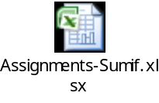

Vlookup / Hlookup
When you are working with large amount of data, updating the individual records with specific set of data would be a challenge. VLookup & HLookup functions in Excel can be used to update the records quickly.
Vertical Lookup could be used to search through one or more columns (vertical) of information
Horizontal Lookup could be used to search through one or more rows (horizontal) of information

- lookup_value: The value to be looked up in the first column of the lookup table.
- table_array: The range that contains the lookup table.
col_index_num: The column number within the table from which the matching value is returned.
- range_lookup: Optional. If TRUE or omitted, an approximate match is returned. (If an exact match is not found, the next largest value that is less than lookup_value is returned.) If FALSE, VLOOKUP will search for an exact match. If VLOOKUP cannot find an exact match, the function returns #N/A.

Click here for the assignment → 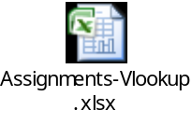

Problem Description: From the below table, band details of the employees need to be updated based on no. of years of experience. Band Table gives the band details.
For Example: Employee Jack has 8 years of experience and should be in band B

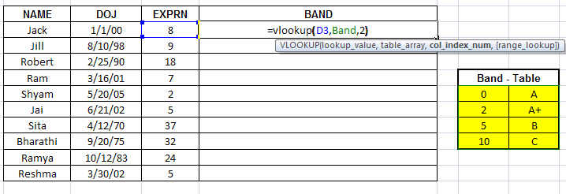
Steps to achieve updating the band details with the help o VLookup function are,

    - Select the Band table (G3:H6)
    - Go to Name Box and type in Band, press enter
    - Go to the cell E3
    - Type as shown in the above table
    - Press enter
    - Copy the function to the other cells

Charts & Graphs
Charts are used for pictorial representation of the data.
Microsoft Excel supports numerous types of charts to help you display data in ways that are meaningful to your audience. When you want to create a chart or change an existing chart, you can choose from a wide range of chart subtypes available

Contents of the charts

- Data : Atleast two sets of data, one to represent the X axis and the other to represent the Y axis
- Axis Labels : Assign labels to the X axis and Y axis
- Legend : Identifies a set of data - if there are more than one set of data on the same axis
- Data Labels : required to display numerical value of a bar chart or section chart

Charts can be either embedded on the same sheet or on a different sheet

Types of Charts

Column Charts:
Column charts are useful for showing data changes over a period of time or for illustrating comparisons among items.
In column charts, categories are typically organized along the horizontal axis and values along the vertical axis.

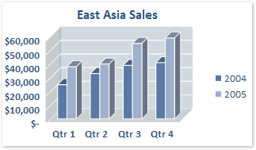

Line charts:
Line charts can display continuous data over time, set against a common scale, and are therefore ideal for showing trends in data at equal intervals. In a line chart, category data is distributed evenly along the horizontal axis, and all value data is distributed evenly along the vertical axis.
You should use a line chart if your category labels are text, and are representing evenly spaced values such as months, quarters, or fiscal years. This is especially true if there are multiple series—for one series, you should consider using a category chart. You should also use a line chart if you have a few evenly spaced numerical labels, especially years. If you have more than ten numerical labels, use a scatter chart instead.

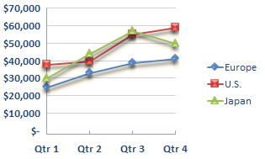

Pie charts:
Pie charts show the size of items in one data series (data series: Related data points that are plotted in a chart. Each data series in a chart has a unique color or pattern and is represented in the chart legend. You can plot one or more data series in a chart. Pie charts have only one data series.), proportional to the sum of the items. You only have one data series that you want to plot.
None of the values that you want to plot are negative. Almost none of the values that you want to plot are zero values. You don't have more than seven categories.
The categories represent parts of the whole pie.

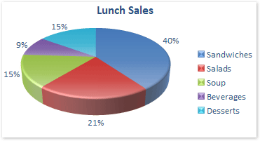

Bar charts:
Bar charts illustrate comparisons among individual items.

Consider using a bar chart when:
The axis labels are long.
The values that are shown are durations.

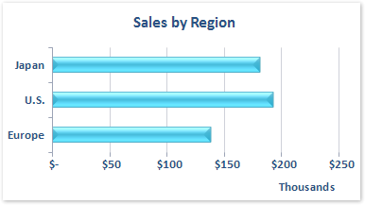

Click here for the assignment → 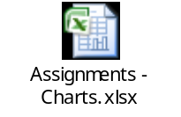

Pivot Table
A PivotTable report is an interactive table that quickly combines and compares large amount of data. You can rotate its rows and columns to see different summaries of the source data, and you can display the details for areas of interest.

Steps to create Pivot Table Report
- Insert à PivotTable Report (Wizard)
- Step 1: Specify the data source (whether Excel list / database / external data)
- Step 2:Specify the range of data (input)
- Step 3: Specify the location (cell range / new worksheet) where you would like to put the pivot table.

Problem description: School Authority has been asked to present the result of 9th Std students in core subjects.
Summary should include the below mentioned data,
    - No. of students in each section
    - Average scores in each subjects by section
    - Max marks scored in each subjects by section

Click here for the assignment → 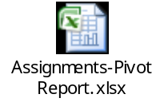

Steps to solve the assignment,
    - Select the table
    - Click on Insert Menu
    - Go to Table Option
    - Click on Pivot Table

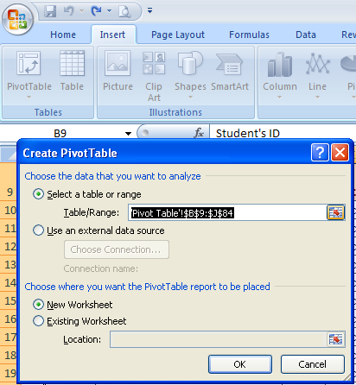

    - Chose where you want Pivot Report to be placed
    - Click on OK
    - Pivot Table Field list is shown as below
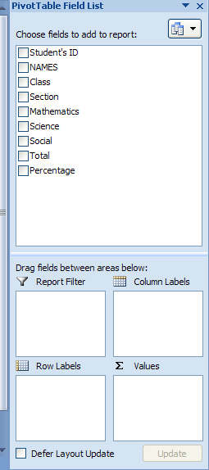

    - Drag and drop the fields on the areas as shown below,
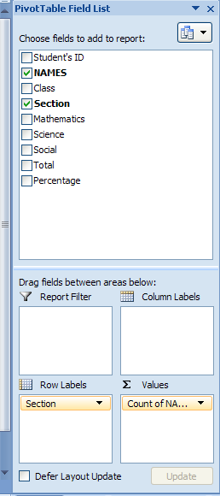

    - Your Pivot table would appear as below,

Row Labels | Count of NAMES
Sec A | 25
Sec B | 25
Sec C | 25
Grand Total | 75

    - Solve the other two assignments as mentioned in the attached workbook

Printing the Excel data
To Print the Excel file,
- Click on Office button
- Click on Print option
- Choose the print range
- Select no. of copies to be printed
- Check the preview before taking the print
- Click on OK
